Default metrics:

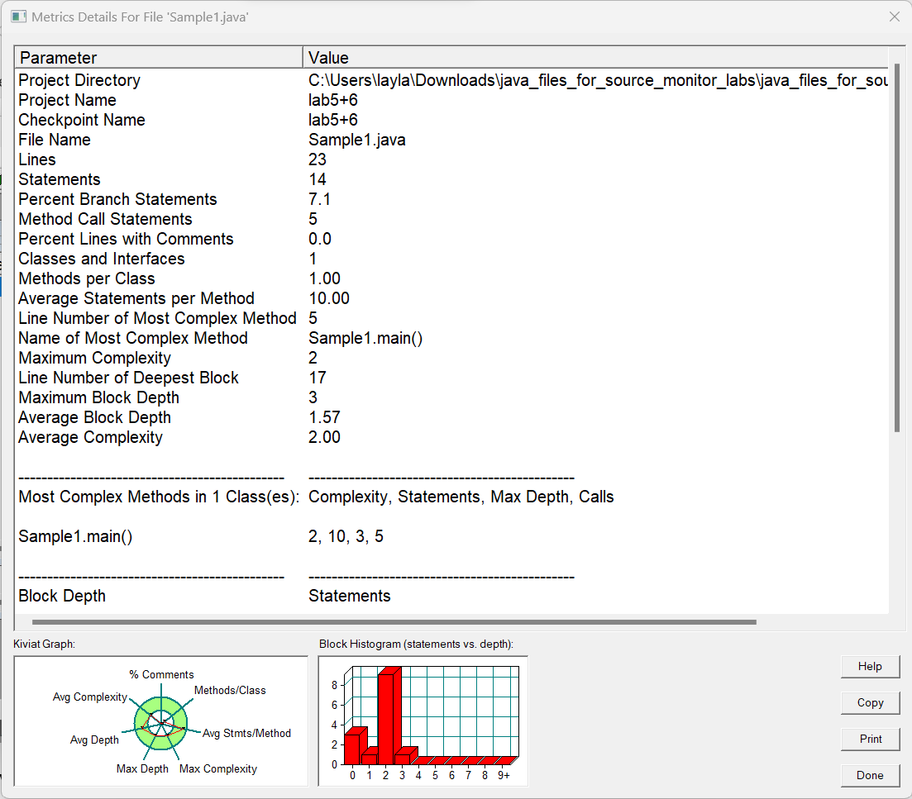

Other metrics:

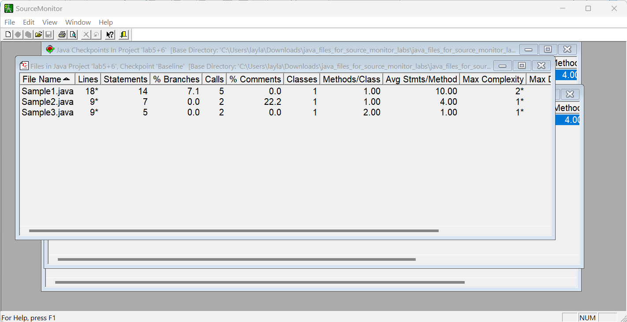

1- Write what measurements/tests you are going to perform? (e.g. code size etc.

see other types of measurements you can perform, in the help section of

SourceMonitor) code size and complexity

2- Which programming language source code files you have tested? java

3- How many files you have tested? (for each programming language) 3 for java

4- What changes (e.g. changing parameters as described above) you made in

each file after first test? Reducing white space in samples 1 and 3.

5- What was the result of tests after changes? The number of lines decreased.

6- Presentation of results in tabular and graphical formats.



